Project Plan

<Project Name> THIS ONE FIRST

WE CAN DO IT!!!!!!!!!!

Focus on the project plan

Student Names:

Ashley Pergoliti (s5311775)

Jonas Sajonas (s5284977)

Jodie Thomson (s118338)

Table of Contents

1.0 Introduction 3

1.1 Problem Background 3

1.2 Scope 3

1.3 Document contents 3

2.0 Work Breakdown Structure 4

3.0 Activity Definition & Estimation 5

4.0 Gantt Chart 6

# Introduction

1. Introduction (5 marks) REMOVE  
Should contain an overview of the project (from a project management/component perspective)  
and mention the scope and outline of the project management document

<toCheck>

The project proposal to <Jodie-AshleyBnbCompany> is contained within this document. The proposal is to create a software solution that extracts and analyses the public Sydney Airbnb data set hosted on kaggle.com. The solution will enable the company to become data-driven and make informed insights and decisions on Airbnb space trends to compete in the market.

The project document includes:

* Background
* Scope
* Work Breakdown Structure
* Activity definition and estimation
* Gantt Chart.

This document only contains the project plan. The software program details are included in the software design document, which will further elaborate on the software solution.

</toCheck>

## Background

* In today's data-driven business landscape, utilising gathered data means gaining the edge in the competition with rivals. <Jodie-AshleyBnbCompany> is at the forefront of the accommodation rivalry in Sydney, they will benefit the most by staying ahead of the competition. Sydney is a sought-after destination for travellers, tourists, and businesses alike. At the same time, Airbnb is a popular choice for accommodation and a lucrative investment choice for property owners. Kaggle.com provides access to Sydney Airbnb Open Data. The data provided includes detailed listings, pricing, calendar variances, reviews, and more.

The proposed software aims to provide a user-friendly, quick access point to specific information and trends about the Sydney Airbnb market. Users can receive charted or listed data tailored to their specific requirements in as few steps as possible.

</revised background> # No examples included. I think it goes to scope.

## Scope *the notes talk about project management scope but in the workshop he said the scope of the software so idk <I think it’s the project management scope cause the software design documents contains all software related stuff>*

Needs more

*The above is more related to the system vision requirements*

*I think this should be more along the lines of:*  
  
The scope of this document is limited to the planning of the project. It will cover the …...

## Document contents

*Include some background information about the problem, the scope and what this document will contain.*

# Work Breakdown Structure

2. Work Breakdown Structure (WBS) (10 marks) REMOVE  
Should be a breakdown of all the different activities involved in completing the project. For Part A: this should contain all of the work involved including preparing the project plan and software design document, as well as all related preparatory/organisation work.

For Part B this should include all of the required implementation, testing and reporting activities. This can be somewhat high level for Part B, but should still contain some reasonable assumptions. This should be presented as some form of diagram/hierarchy.

*This section should include the work breakdown structure for the whole project. The elements from the WBS should be used to generate your activity definition and those activities should then be scheduled in the Gantt Chart. Remember to consider ALL project activities – anything you do or will need to do should be included in the WBS*

*WBS’s are usually presented as some kind of hierarchical diagram/chart etc. The details what is involved each work unit should be provided in section 3:* ***Activity Definition***

*You do NOT need to do a WBS Dictionary for this project – the activity definition (whilst slightly different) will suffice. The WBS is focussed on SCOPE. The Activity definition is focussed on TIME.*

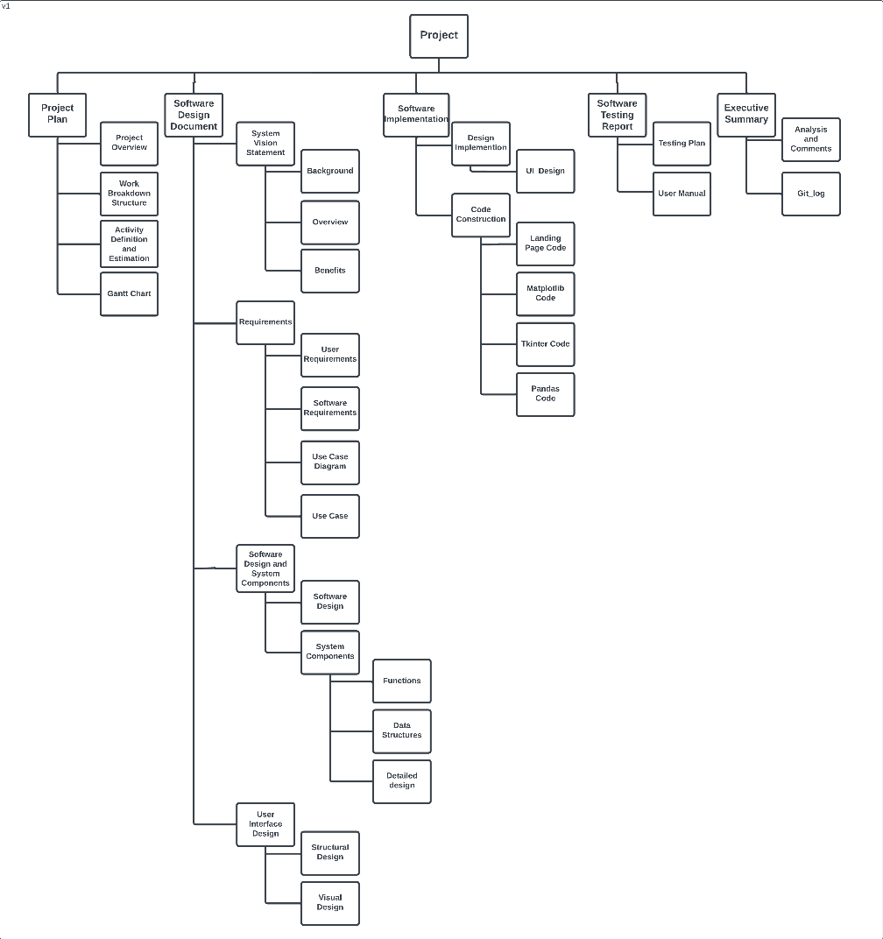

# Activity Definition & Estimation

# adjust total times for each section as things over lap

3. Activity Definition & Estimation (10 marks) REMOVE

|  |  |  |  |
| --- | --- | --- | --- |
| **Gantt Number** | **Item** | **Activity Details** | **Time Estimation** |
| **1** | **Project Plan** |  | **1 week** |
| 1.1 | Project Overview | Outline of the project | 1 days |
| 1.2 | Work Breakdown Structure | Formulate the WBS hierarchy | 2 days |
| 1.3 | Activity Definition and Estimation | Describe the activities and duration estimates | 2 days |
| 1.4 | Gantt Chart | Display schedule and progress of tasks | 2 days |
| **2** | **Software Design Document** | **? Round up to weeks?** | **19 days** |
| **2.1** | **System Vision Statement** | **Declare the purpose, goals and value the system aims to provide** | **6 hours** |
| 2.1.1 | Background | !Why the software solution is being made??? | 2 hours |
| 2.1.2 | Overview | Scope of the system | 2 hours |
| 2.1.3 | Benefits | Benefits of the software to the company | 2 hours |
| **2.2** | **Requirements** |  | **3 days** |
| 2.2.1 | User Requirements | Description of what the user expects from the system | 1 day |
| 2.2.2 | Software Requirements | Description of what the software can deliver | 1 day |
| 2.2.3 | Use Case Diagram | Visual representation of interactions between actors and system | 4 hours |
| 2.2.4 | Use Cases | Description of how users interact with the system | 1 day |
| **2.3** | **Software Design and System Components** |  | **10 days** |
| 2.3.1 | Software Design | Diagram/hierarchy that shows | 1 day |
| 2.3.2 | System Components | The design of the different aspects of the app | 9 days |
| 2.3.2.1 | Functions | List functions required | 2 days |
| 2.3.2.2 | Data Structures | Layout of …. Diagrams? | 2 days |
| 2.3.2.3 | Detailed design | pseudocode | 5 days |
| **2.4** | **User Interface Design** |  | **5 days** |
| 2.4.1 | Structural Design | Inc hierarchy | 1 day |
| 2.4.2 | Visual Design | Inc wireframes | 4 days |
| **3** | **Software Implementation** | **The implementation of the software** | **13 days** |
| **3.1** | **Design Implementation** |  | **3 days** |
| 3.1.1 | UI Design | User interface design | 3 days |
| **3.2** | **Code Construction** | **The construction of all aspects of the code** | **10 days** |
| 3.2.1 | Landing Page Code | The home page of the application | 4 days |
| 3.2.2 | Matplotlib Code | The code for creating the graph | 3 days |
| 3.2.3 | Tkinter Code/wxPython | The code for creating the UI design of the app | 3 days |
| 3.2.4 | Pandas Code | The code for interacting with Excel documents | 3 days |
| **4** | **Software Testing Report** |  |  |
| 4.1 | Testing Plan | Design testing | 5 days |
| 4.2 | Ongoing testing |  | ???? |
| 4.3 | User Manual | Create the Manual for users | 7 days |
| **5** | **Executive Summary** |  |  |
| 5.1 | Analysis and Comments | Project report analysis and | 1day |
| 5.2 | Git_log | Summary of the Git log | 1hr |
|  |  |  |  |
|  | **Project Completion** |  |  |

For each item in the WBS, the item should be explained in detail and include a time estimate that is reasonable.

<do we need to add assign proj manager, develop proj charter, meet with stake holders?>

*From your WBS, define the activities required for your project. You will revise this document and add more detail for part B as you discover more about the project.*

*Each activity should be clearly identified by a number and should match up to your Gantt chart. You should provide some estimations for the time you think each activity will take. This should make it easy to prepare your Gantt chart.*

# Gantt Chart Last

Gantt chart (15 marks) REMOVE  
All of the items in the Activity definition should be listed in the Gantt chart with the relevant estimates and scheduling. The students should have also tracked the actual start time and time taken. Also need to submit the Gantt chart.xlsx

*This section should contain your Gantt chart. The items in the Gantt chart should match the activity definition from section 3. You should also submit your Gantt chart file separately.*